- Press Release, April 20th 2021 -

Shoreline Hospitality offers a bespoke ‘Reopening Package’ aimed at leisure hotels to prepare for the travel rebound

While times are difficult for any hotelier across the globe, anyone needs to anticipate business returning to their respective regions. People will soon be travelling again, with vaccination programs progressing everywhere.

It would be wrong to assume that one could simply continue to do whatever has been done pre-pandemic!

Digitization and sustainability aspects, just to mention two specific examples, must be a top priority for every organization to become ‘fit’ for the future and stay ahead of its competition.

Shoreline Hospitality is offering a special ‘Hotel & Restaurant Reopening Package’ (www.shoreline-hospitality.com/covid-special), supporting any business owner with an independent expertise and to determine what adjustments need to be made to succeed long-term.

As professional consultants for the hotel and catering industry, the team at Shoreline Hospitality is confident that an objective review of any company is invaluable, especially at this critical and sensitive time.

Since the industry is made up of individualists and that no two companies are alike, a bespoke package would be presented according to individual needs and requirements.

As part of a completely non-binding initial consultation, a detailed outline of the project will be provided.

Shoreline Hospitality
Info@shoreline-hospitality.com

__________________________________
About Shoreline Hospitality

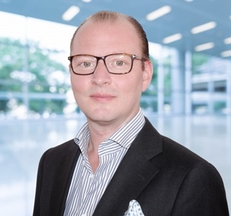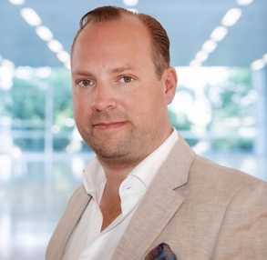

Shoreline Hospitality, founded in 2019 by Andreas Acker & David Nuenemann, offers practice-oriented consulting services with a focus on leisure hotels & resorts as well as restaurants.

Shoreline's goal is not only to show opportunities and improvement possibilities, but also to define conclusive measures and then implement them together with their respective clients.

Due to their many years of international experience, extensive knowledge of the hotel market, its competitors and current developments as well as an objective perspective from outside, Shoreline has helped numerous companies to gain significant competitive advantages and increase their operating results.

Shoreline strives to specifically provide new impulses and bring in current trends.

Particularly in times of crisis and uncertainty, the team at Shoreline helps organizations to identify problems at an early stage, highlight solutions for known problems or scrutinize concepts from the ground up and therefore assist to make every company 'fit' for the future.

Learn more & contact www.shoreline-hospitality.com.

Press / media kits can be found here:
www.shoreline-hospitality.com/press-media-download

